**Java Development**

Environment Setup

Contents

Installing the Java Development Kit (JDK) 3

Installing an IDE (Eclipse) 6

Installing an Application Server (WildFly) 8

Integrating Your Application Server with Your IDE (JBoss Middleware) 9

Installing a Database (PostgreSQL) 13

# Installing the Java Development Kit (JDK)

Before we can get started, we will need to download and install some necessary software, so that we can design and build full Java applications. The first thing you will need to download is the Java Development Kit, or JDK. You can find the download link in the Reference URL section of the “Environment Setup” task, or here:

* [Java Development Kit Download](http://www.oracle.com/technetwork/java/javase/downloads/index-jsp-138363.html)

On the download page…

1. Click a link to download the JDK. The latest version might be different than what is shown here:

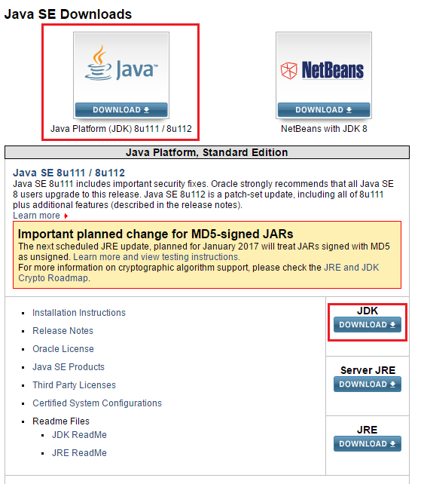

1. Java versions are given as <Major Version><’u’ for “update”><Minor Version> as shown below. Find the latest version, accept the license agreement, and then download the version appropriate to your operating system.

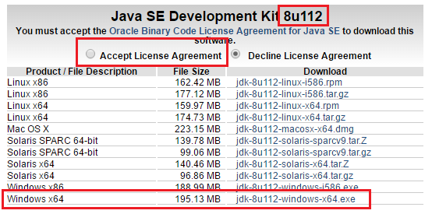

Now, from your download directory…

1. Run the installer you just downloaded. Click “Next >” at the first window (Setup):

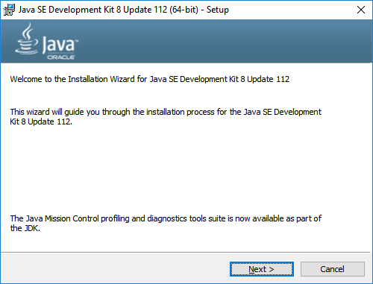

1. Click “Next >” at the second window (Custom Setup):

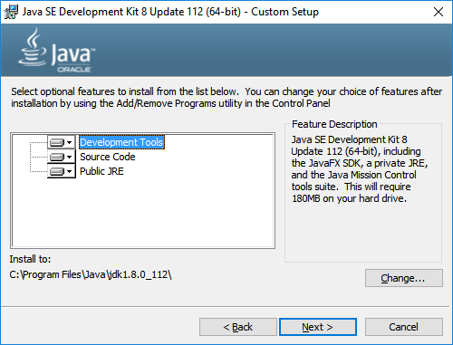

1. Let the extraction run. On the next window (Destination Folder), click next:

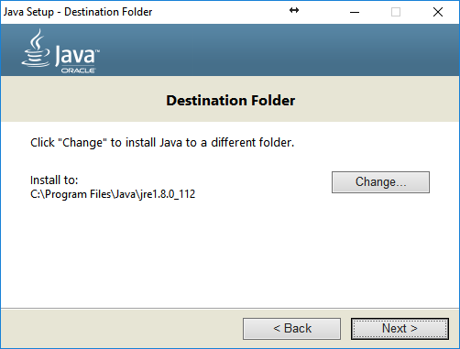

1. Java will now be installed to the previously indicated destination. When the process is complete, click close.

# Installing an IDE (Eclipse)

Now that we have Java installed, we will need to download Eclipse. Eclipse is an IDE, or Integrated Development Environment. This is where you will write, deploy and test your code. A good IDE brings many features to the table to make your life easier, like error checking, warnings about dangerous code, and management of any 3rd-party libraries or tools you might be using. You can get the latest version of Eclipse from the download link provided in the reference section, or from here:

* [Eclipse Download](https://eclipse.org/downloads/eclipse-packages/)

On the download page…

1. Select your OS from the drop-down list, and download the **“Eclipse IDE for Java EE Developers”** as appropriate for your OS:

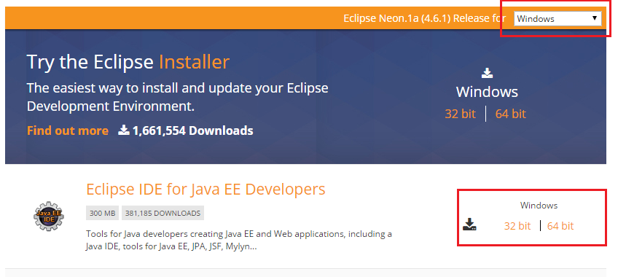

|  |
| --- |
| **NOTE: Eclipse versions**  There are different versions of Eclipse and they are all given a code name. You can use the latest one.  The list of latest names for the versions are below (listed from latest to earliest):   * Oxygen (Version 4.7) * Neon (Version 4.6) * Mars (Version 4.5) * Kepler (Version 4.4) * …   The screenshots used throughout this guide were created using Eclipse Mars, but you can use this guide for your version as it will be similar. |

Now, from your download directory…

1. The Eclipse download is packaged inside a ZIP file. Unzip the downloaded ZIP archive to a destination of your choosing.
2. Unlike Java, there's nothing to install with Eclipse - the entire application is contained in the folder you've unzipped! Move the unzipped folder to somewhere safe.
3. For ease of access, open the eclipse folder. Inside, Right-click the eclipse application, and select, "Create Shortcut." Place this shortcut on your desktop.

|  |
| --- |
| **NOTE: Using other IDEs (NetBeans,IntelliJ, etc.)**  If you are familiar with other tools such as **NetBeans** or **IntelliJ** and are more comfortable with those tools then you can use them.  If you choose to do so, however, you will have to follow instructions for your tools to download and install the application server WildFly and any plugins necessary for it to connect with it.  Please consult the websites for those tools on instructions for how to setup your application server. |

*(continue to next page)*

# Installing an Application Server (WildFly)

Now that you have Java and Eclipse, let's get your application server installed. The application server is a type of web server that is capable of hosting and running Java applications. With this software running on your machine, you can write web applications. and test them locally. The application we will be using is called WildFly, and setup is pretty simple. Use the download link in the reference section to get started. That link is also here:

* [WildFly Download](http://wildfly.org/downloads/)

On the download page…

1. Select the ZIP download for the latest version of the “**Java EEx Full & Web Distribution.**” The latest version might be different than what is shown here:

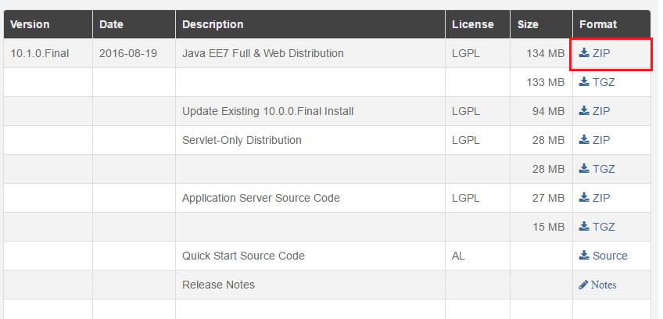

Now, from your download directory…

1. Like Eclipse, WildFly requires no installation - it's nicely self-contained inside a ZIP archive. Unzip it to a location of your choosing.

|  |
| --- |
| **Warning!** (Windows Users)  Do not use the C:\Program Files or C:\Program Files (x86) directories for your WildFly install.  Your application will have permission-related issues when you try to run the server.  Instead, create a new directory under the C:\ drive called **apps** (so it’ll be C:\apps) and place your WildFly ZIP there. |

1. You will be controlling WildFly from within Eclipse, so there is no need to create a shortcut.

|  |
| --- |
| **NOTE: WildFly and JBoss**  The original name for WildFly is JBoss. Since version 9 of the application server, the company has used the name WildFly instead.  Please consider this when searching for further information regarding the usage of WildFly, the name JBoss may be used as a replacement. |

*(continue to next page)*

# Integrating Your Application Server with Your IDE (JBoss Middleware)

Now that we have WildFly and Eclipse, we will install an adapter that will let us deploy our Java web applications to our WildFly application server from directly inside Eclipse.

1. Open up Eclipse
2. Now, at the bottom of the screen, you may have a view tab labeled "Servers." If you do not, go to Window -> Show View -> Other..., search for 'Servers," and click add.

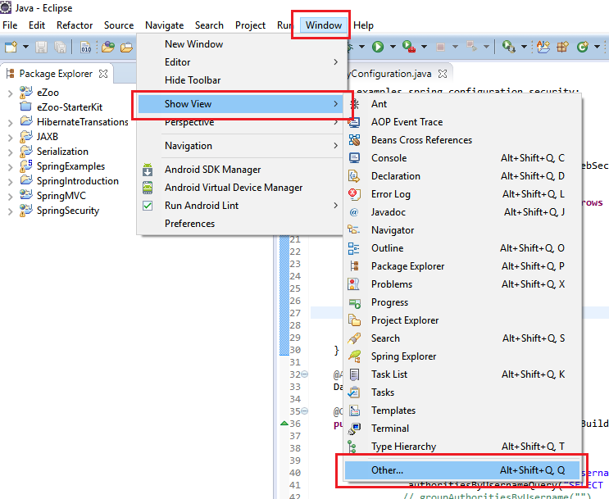

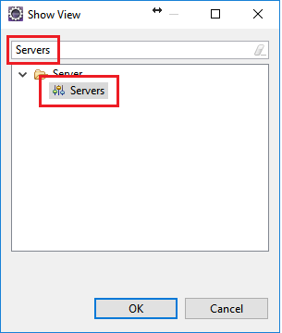

1. In the "Servers" view, right-click anywhere, and select New -> Server.

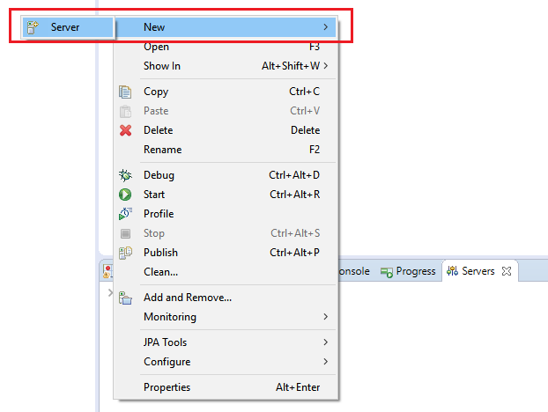

1. In the “Define a New Server” window, find the folder labeled “Red Hat JBoss Middleware” and expand it. Inside this folder, select the “JBoss AS, WildFly, & EAP Server Tools” option, and click “Next”.

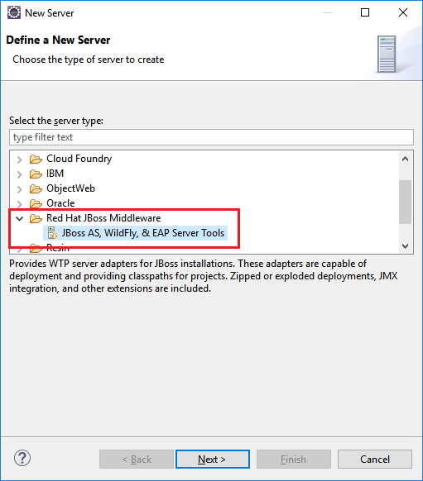

Eclipse will now connect to the JBoss software repository to download and install the latest version of the JBoss server adapters. This may take a while, and you can see your progress in the lower-right corner of your Eclipse window. When this is process is complete, you may continue.

1. Return to the "Define a new server" window by right-clicking anywhere in the “Servers” view and selecting New -> Server. Now you will have a folder named “JBoss Community”. Open this folder, select your version of WildFly, and click next:

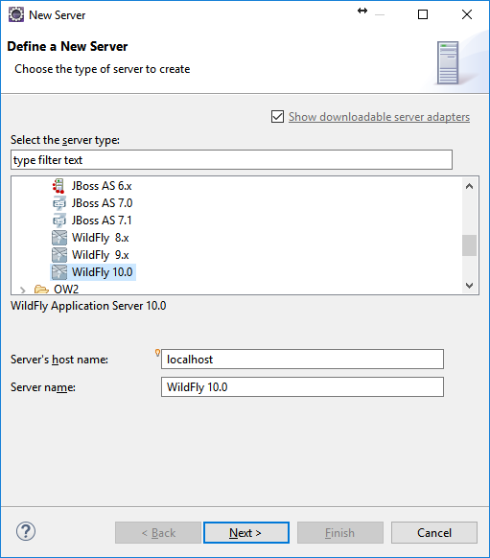

1. Go ahead and click next again:

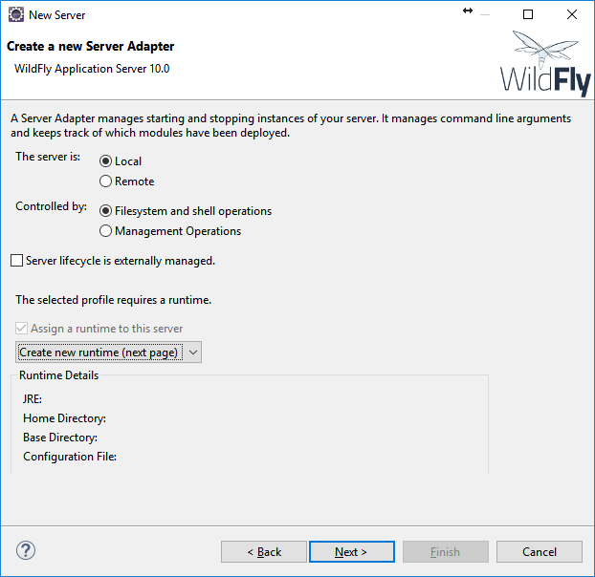

1. Now, you will need to define a runtime. All you need to do is select the folder where you installed the WildFly server. Then click finish:

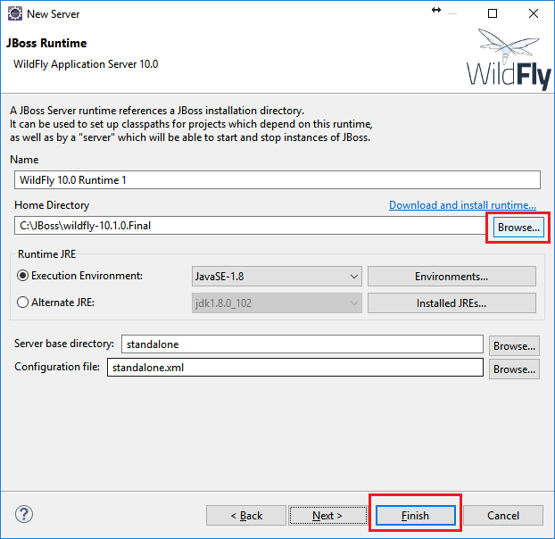

# Installing a Database (PostgreSQL)

Finally, we will need to install PostgreSQL Database. This is the database we will be using for our applications to store information. PostgreSQL is the largest, most widely-used open source database, and is widely used in the Software Development industry. You can find a download link in the Reference URL section of the “Environment Setup” task, or below:

* [PostgreSQL Download](http://www.enterprisedb.com/products-services-training/pgdownload) (Windows)
* [PostgreSQL Download (Mac)](https://postgresapp.com/)

|  |
| --- |
| **Mac Users Only**  Please skip the steps 1 through 7 below and follow the instructions on the website that is posted as the Reference Link. You will be setting up another tool call Postgres.app instead of EnterpriseDB.  Postgres.app can be downloaded from: https://postgresapp.com/  Once your Postgres.app is setup and you’ve followed the steps to **initialize your database**. You can download pgAdmin to use to issue SQL commands to your database.  **NOTE**: You may have to download pgAdmin separately.  You can use this link: https://www.pgadmin.org/download/ |

On the download page…

1. Select the latest version for your operating system. The latest version may be different than shown here:

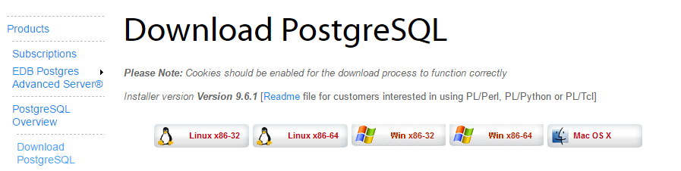

Now, from your download directory…

1. Run the downloaded installer. On the first window, click “Next”:

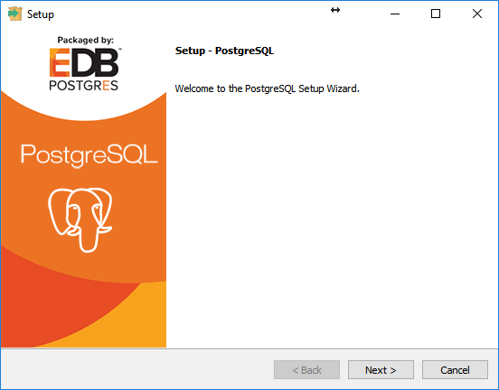

1. Select an installation directory, and click “Next”:

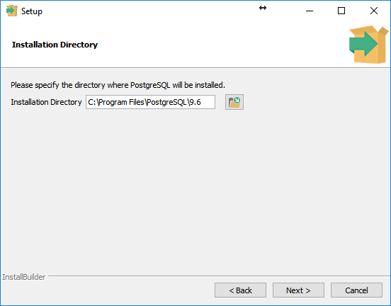

1. Select a data directory, where your database’s data files will be stored, and click “Next”:

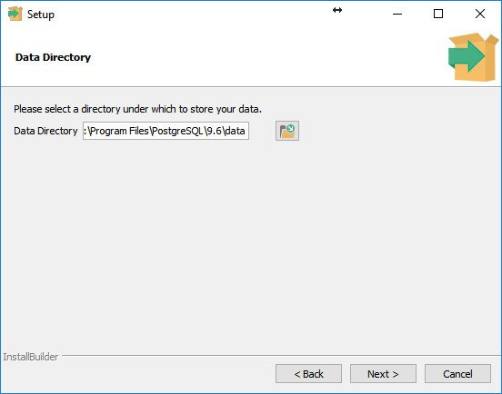

1. Enter a password for the default “postgres” account. You MUST remember this password! As a matter of fact, since this is for developmental purposes, just set the password to “password”. Yes, we know. Just do it. Click “Next” when done:

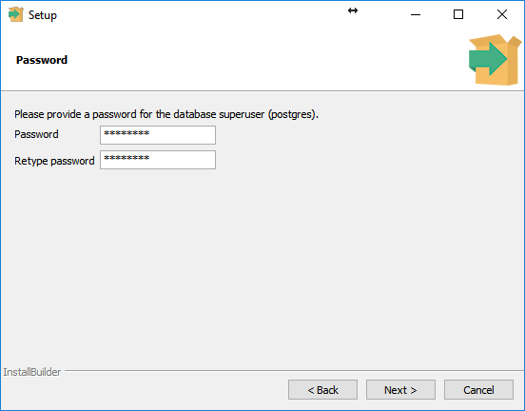

1. Select a port. The default is acceptable, and you should not change this unless you understand what you are doing. Click “Next” when done:

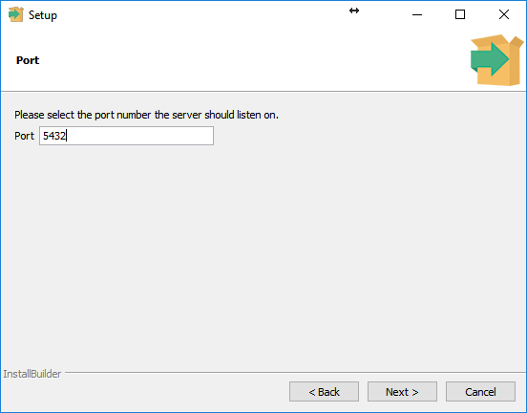

1. Select a locale – again, the default is fine. Click “Next” when done:

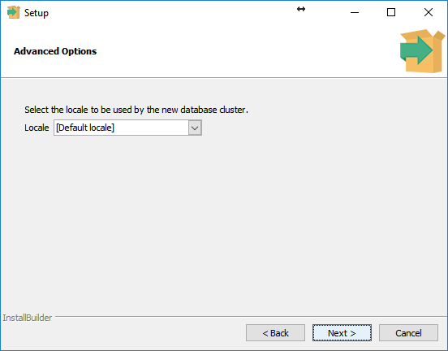

1. Click “Next” again to begin installation. When installation has completed, you will be prompted to continue installing Stack Builder. **Uncheck the box, and click Finish. Do not install Stack Builder**, unless of course you know what you are doing:

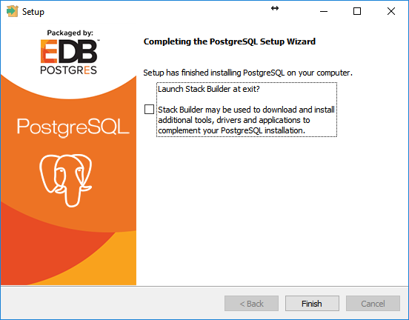

1. Installing PostgreSQL Database will also have installed the pgAdmin utility if you’re a Windows or Linux user. If you’re a Mac user, you have to download pgAdmin separately.

Once pgAdmin is downloaded and installed, open pgAdmin and try to expand the server list on the left:

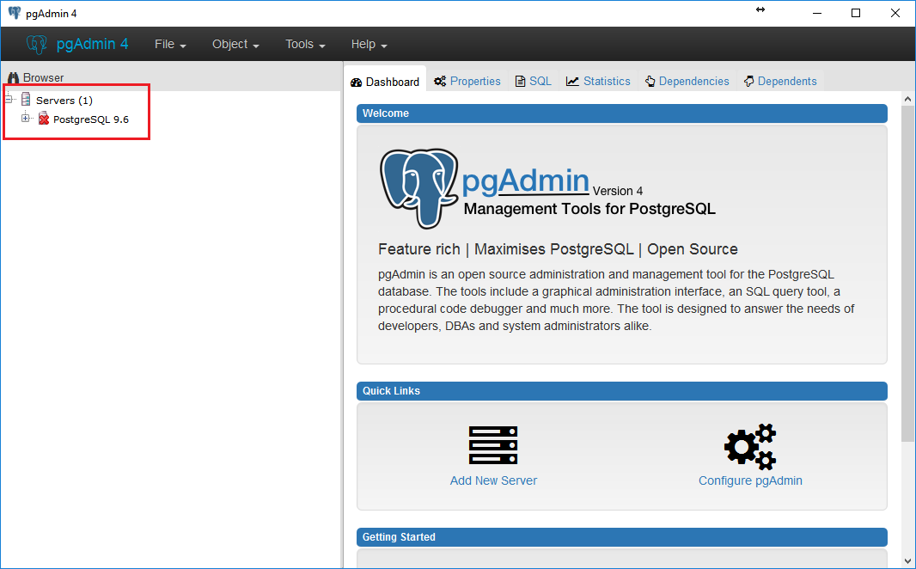

If you don’t have any servers, see the Troubleshooting section at the end of this document.

1. This will prompt you for the password for the user “postgres” that you created in Step 4. Enter that password, and check the box to remember it:

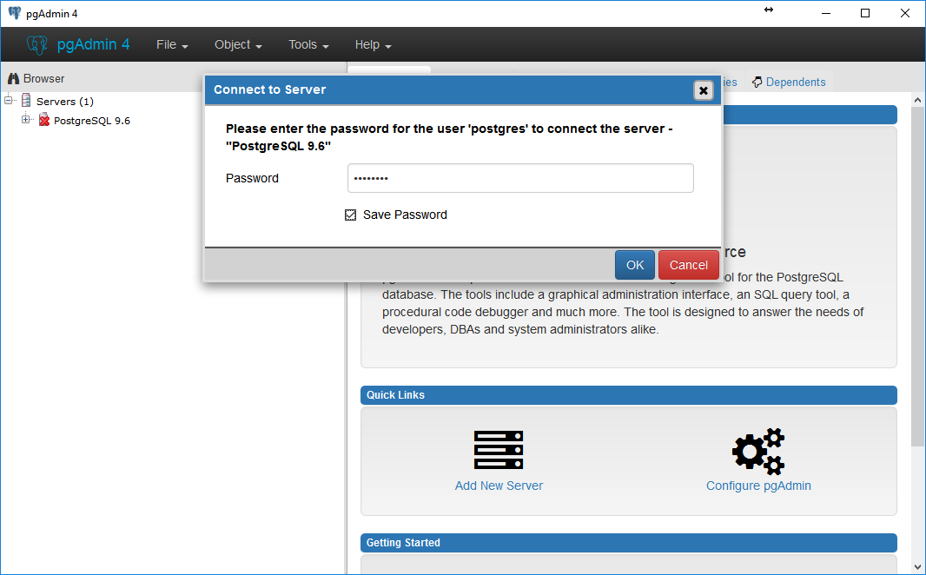

1. Now you will be able to explore PostgreSQL Database fully. We'll play around with these tools more in the future, but for now, you have all the tools needed to proceed:

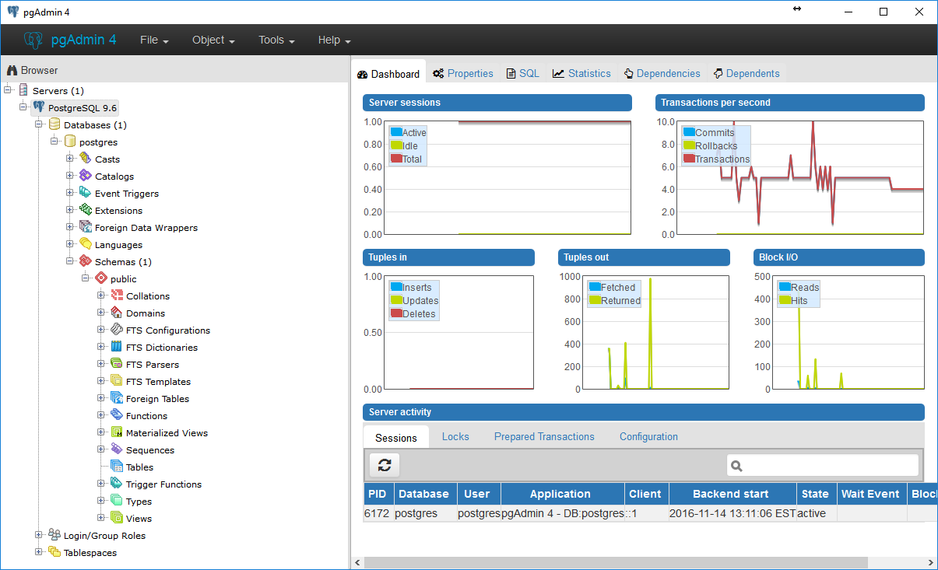

# Troubleshooting

1. I can’t find my database server in pgAdmin

You'll have to define your server manually. For some reason, pgAdmin didn't link to your default server.

Click on the **Add New Server** option under Quick Links panel.

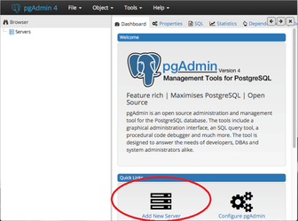

You'll then be presented with a dialog to specify the server name. Type in **PostgreSQL 9.x** or other version number.

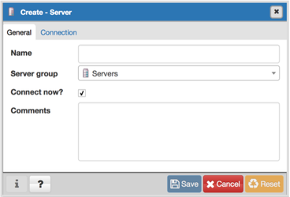

Click on the Connection tab.

Fill out the following details:

* **Host**: localhost
* **Port**: 5432
* **Maintenance database**: postgres
* **User name**: postgres
* **Password**: password
* **Save Password:** (check this box)
* **Role** (leave blank)
* **SSL mode** (leave to default value)

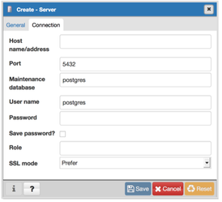

Click **Save**. Your database should be setup now in pgAdmin and should attempt to connect to it automatically.

|  |
| --- |
| **Still Not Working?**  If pgAdmin cannot connect to your database then double check the following:  1. Verify that you've typed in the correct credentials  2. Verify that your server is running |